Dealing with Cyberbullying
in the 21st Century
Table of Contents
Introduction and Purpose 2
Cyberbullying Case Report 3
Background 3
Literature Review 3
Case Studies 4
Case Study 1: Amanda Nickerson 4
Case Study 2: Zhu Yilong 7
Case 3: Iskander v Barcos [2023] VCC 2074 9
The Crux of Cyberbullying 10
Solutions 10
Project Report Summary 12
What I did 12
What was different from my original plan? 12
Challenges 12
Conclusion 13

Introduction and Purpose
Cyberbullying in this report is defined as using technology to hurt or embarrass someone (Victoria Government Department of Health, 2024). The scope of my project is a variety of high-profile cyberbullying cases, to illustrate the different types of bullying and derive countermeasures for security based on case analysis.
Why did I decide to do this research? I am inspired by the book Cyber Attack Survival Manual, which talks about an online character attack against a successful businesswoman. It got me thinking there isn’t much recourse for an adult when this reputational damage happens. The more I read, the more I find that adults are also affected by cyberbullying and that the internet is a relatively new concept to all of us. Not everyone is fully equipped to deal with it, even as adults. Children are even more susceptible. We interact with the internet daily but don’t have the tools to navigate it safely, that is a scary thought.

Cyberbullying Case Report

Background
Cyberbullying is when technology is used to hurt or embarrass someone or to make them afraid (Victoria Government Department of Health, 2024). It can affect everyone, including children, teens, and adults (Cyberbullying Research Centre, 2011).
Cyberbullying campaigns are an extreme form of cyberbullying. It is defined in my research as an effort (organized or otherwise) to popularise misinformation or private information about a victim online, with the intent to harm the victim’s reputation or distress them psychologically.
(Data based on APS, 2020)

In 2020, a study of over 20,000 people indicated that 40.5% of young adults reported that they had been cyberbullied (APS, 2020). The fact is, cyberbullying decreases with age, but exists in all age groups. In fact, Patchin (2015) in an article points out more adults are turning to legal help for cyberbullying.

Literature Review

Characteristics
- Characteristics shared with cyberbullying:
  - 1. Primarily psychological
  - 2. Attacks social status
  - 3. Can occur 24 hours a day (BackgroundChecks.org, 2024)
  - 4. Invisibility:
    - The effects are not obvious
    - The tactics are hidden and private
    - The anonymity adds a layer of complexity to trace who is the perpetrator and why the attack was initiated
Common Tactics
These types of bullying can take many forms, including:
  - spreading rumours on social media about a person to upset relationships or careers;
  - derailing potential businesses for a company by give false reviews about their products;
  - Impersonating someone to solicit information or
  - creating a perfect storm to attack a competitor in the same industry and more.
  - Trolling
  - Doxing – researching or disclosing an individual's private data or identifiable information to incite harassment.

Existing policies and frameworks deal with the urgently illegal, for example, child porn. “The law is the last line of moral defense”, says criminal law professor Luo Xiang. Which means that the law is usually only equipped to deal with gross violations, and as N. Selby states in his book “frequently lags behind”.
The good news is, there are several digital frameworks and guidelines that are being updated now. Including the increased enforcement powers in Australia, including the eSafety Commissioner being granted power to ask platforms to assist in takedowns. The primary target for help is children and vulnerable communities, for example, image abuse of women.

Case Studies

Case Study 1: Amanda Nickerson
- Summary: Amanda Nickerson, with a 17-year career in the oil and gas industry was cyberstalked for 2 years (2014-2016).

What happened:
- Attacker created fake profiles on escort sites, cheater sites, fake social media sites
- Attacker threatened her over the phone and physically sent mail to company to harass her
- Attacker moved on to attack her friends and family and created false reviews for her company
- Attacker demands that she break up with her boyfriend in return for stopping the attack

What was under attack:
- Her reputation, professionally and personally
- Her health, especially mental health
- Her personal relationships and support system
- Her company’s reputation and her livelihood
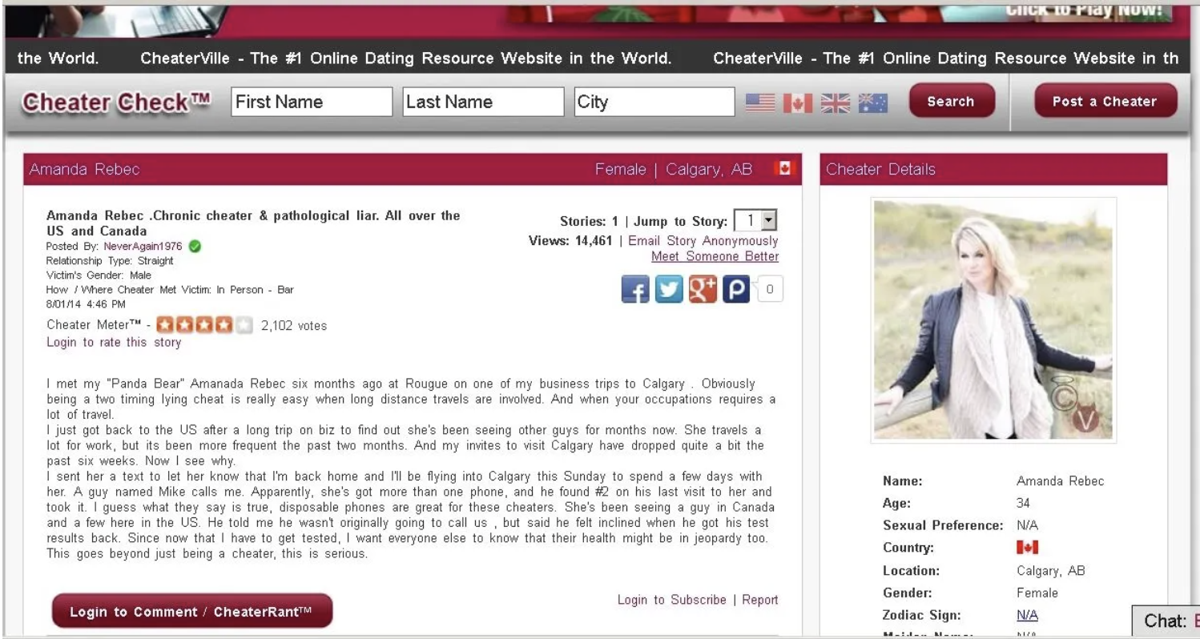

Impact:
- Loss of reputation “walk into business meetings and … asked about intimate things”
  - Loss of livelihood - “I ended up losing contracts and ultimately my job.”
  - Psychological distress – “I couldn’t trust anyone around me.”
- Betrayal/loss of support from others - “Some even exploited the situation to pressure me for money, blaming me for the impact my stalker had on their lives.”

Resolution:
- Unfortunately, the police and FBI could not help her since her case was low priority compared to child pornography or murder.
- She did not give in to the demands of the attacker and wrote a blog to detail her experience and share her voice. She had friends and family who were supporting her.
- A forensic cyber investigator and crime analyst took her case and helped her increase operational security and helped her regain mental resilience.
- After two years, the cyberstalker apologized on Tumbler and stopped suddenly.

Lessons:
PREVENTION & PROACTIVE MEASURES ON CONFIDENTIALITY AND INTEGRITY:
- Remove metadata from public photos and make sure they are all watermarked
- DMCA takedown of unauthorized use of copyright images on social media sites
- Password protection:
    - Strong passwords and 2-step authentication for sites
    - Different passwords for personal and work, and change all passwords
    - Install a password keeper
- Control your narrative - “…bolster your legitimate online presence and keep it up to date. The less there is online about you, the easier it is for trolls and stalkers to make your life difficult. Laws lag far behind modern tech… you’ll end up having to hire lawyers to do takedowns.” (H. Vescent & N. Selby, 2020)
Note: This is a case where the attacker changes a variety of tactics, but their true intention doesn’t surface until they issue the ultimatum a few months later.

Case Study 2: Zhu Yilong
Summary:
Sudden fame for an actor with a 10-year career. A myriad of attacks from different agents targeted the actor, his fans, and his reputation.
Background:
Zhu Yilong (born in 1988) is a Chinese actor who began his career in 2009. In 2018, he experienced a surge in popularity through an online fantasy drama.
Challenges During Rise to Fame:
When someone rises to fame so quickly, they are most vulnerable to:
- Trolls and Hate Comments: The influx of fans often brings negative comments, causing psychological impacts.
- Unstable Fanbase: The fanbase may be susceptible to manipulation.
- Loss of Privacy: Increased public scrutiny can impact personal relationships and work.
Observable Events:
What happened | Target | Aim & Impact | Resolution
A flood of bad reviews was published under movies and TV series the actor has participated in. | Public opinion  Professional career | Negative reviews bring down the rating of the actor’s shows, dissuading others from watching | Fans countered by creating accounts on review websites and posting positive reviews to counter negative reviews.
1. A barrage of hate comments and negative comments were posted about actor’s appearance and acting abilities on social media  2. Bots and paid media accounts repeatedly pushed the content under the tags of the actor.  3. Positive tags and popular search results linked to the actor on Baidu and social media were selectively removed. | Fanbase  Public opinion  Actor mental health | 1. Influencing public opinion by creating a negative first impression about the actors and the shows he performs in  2. Driving fans away using repetition and negativity  3. Filling the actor’s tag and messages with negativity to impact anyone searching for him | Fans self-opted into posting more positive pictures and reviews with different positive tags and reporting falsified/negative comments.
Fandom wars were incited through baiting, professional trolls or via paid media accounts | Fanbase  Public opinion | Aims to create an impression that “this actor’s fans are crazy and problematic”, which is culturally frowned upon, creating a base level of negative public impression | Fandom adopted the saying “Attention is precious, don’t give them any attention” and chose not to react
Brand accounts associated with the actor have been harassed on social media. Negative comments and false reviews about the brand and products were posted on social media. | Sponsors  Actor financials | Aims to frighten or scare away sponsors that support the actor and attack the actor financially | Brand account limited to “top comments only”, and continued sponsorship
Misleading post insinuating the actor was rude and inconsiderate. Misleading post insinuating the actor did not perform the roles as specified, published by colleague. | Actor reputation  Professional career | Aims to tarnish actor reputation.  The misleading post was created to take the heat off another actor, who performed badly in the same show. | Other colleagues in the industry spoke up about the actor’s politeness and work ethic.  Evidence of original play provided by fans to dispel rumours.  Colleague deleted the misleading post.
Paparazzi photo of the actor with a woman, creating the rumour of a “hidden girlfriend”, paired with multiple media releases on news sites. | Fanbase  General public | This is a tactic frequently used on idol figures. Aims to chip away some of the more parasocial fanbase who don’t want idols to have girlfriends. | There was not much reaction from the fanbase about the rumour, possibly because the majority of fanbase is not built on the “girlfriend fantasy”. The rumours turned out to be false very quickly, as the woman is the actor’s long-standing agent.

Lessons from Zhu Yilong
- The actor chose to focus on acting and making real-life connections to produce better shows instead and speaking of improvement in interviews instead of responding to negative comments on social media.
- Keep in mind what is important in real life, not just what is said online. Real-life fight with real life tools. Real life > online. Real life consequences are more important.
- A separation of online. In the case of Zhuyilong, he keeps producing good movies as an actor and keeps improving his acting abilities. The influence gained is being used to realise that into connections, procuring better resources and better movies. —> It needs to launch off a platform.
- Keeping private life private. Making sure there is a clear line between fans and actors, despite giving appreciation. Clarifying the relationship: the goal of an actor is to bring more good movies to people. Fans who appreciate and support that can appreciate but should focus on their own lives without burdening fans financially. Acts that encourage parasocial relationships are not encouraged.
- When you’re given such an influence, action and words are equally important. A simple “don’t dox people” and make sure what you tolerate and don’t approve of can help.
- Ensure you have a strong support network. Colleagues, managers who can vouch for your work ethic, friends and families who will stand by your corner are important. Strengthen your real-life connections.
- Legal help is your best bet.
- Pick important things to address. Not all allegations deserve attention. Remember that it is all over the news the next day. Not all truth needs to be revealed or responded to, to avoid the trap of over-explaining. Private information may not always need to be divulged.
- With legal, and important things, it is important to respond as quickly as possible with a statement to prevent further rumours. It must be concrete what you say and with time priority.
- Other people may hop on the train of trolling or negativity.

Case 3: Iskander v Barcos [2023] VCC 2074
Summary:
In 2022, Auto trimmer Michael Iskander was falsely accused by his former employer, David Barcos of BNB Autohaus, for scamming a customer (Davis, W. 2024).
Situation and Target:
Barcos posted on his business Facebook page defaming Iskander, targeting Iskander’s business reputation.
Impact & Resolution:
The business Facebook page had 20,000 followers and this could severely damage Iskander’s livelihood and reputation. As such, Iskander sued Barcos, Barcos defaulted.
The judge found fabricated evidence and malicious intent to harm Iskander’s business and awarded $90,000 in damages.

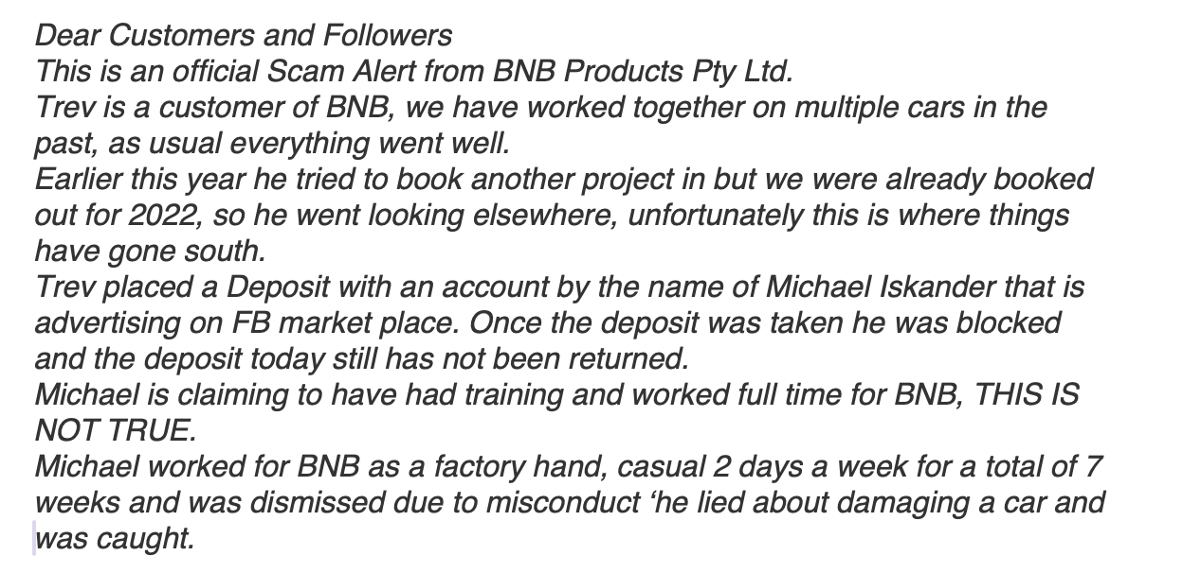
Facebook post (Davis, W. 2024)

PREVENTION & PROACTIVE MEASURES ON AVAILABILITY AND INTEGRITY:
- Screenshot/record evidence to ensure that it is available and cannot be tampered with/deleted
- Consulting lawyers and using the appropriate legal tools, including defamation act and the serious harm threshold to ensure integrity of business and reputation is mended.
- NOTE: This is a case where the perpetrator is identifiable, and the intent is clear.

The Crux of Cyberbullying
Intent to hurt and access.
- Access to private accounts (including breaking in, password access)
- Access to private information (including photos, texts)
- Access to real-time information (home address, phone number, real-time location)
- Knowing what hurts (access to phonebook contacts, company, colleagues), and access to those people (fans, community forums(need moderation), company review page)
- Access to inbox (email address, comment section, inbox)
- Utilisation of public space and influence to accuse someone of something fill the news and internet space with information about them

Solutions
Keeping yourself safe physically and mentally is the top priority.
Protect yourself:
- Keep operationally safe (privacy, private life, and details, protect your passwords)
- Selective and careful interaction online, be careful about engaging in debates or comment wars, and take control by blocking and reducing exposure to mean comments. Moderated communities provide a layer of protection.
- Monitor mood when browsing online, close the connection and say ‘no’ to negativity.
- Build up support network and bolster a strong narrative of your personal brand online and in real life (e.g. with your colleagues).
- Setting strong boundaries between real-life and online
- Do not react, especially to incendiary posts and comments (Davis, W. 2024, Vescent, H. and Selby, N 2020).
Defend yourself:
- Do not handle cyberbullying alone, find trusted friends, family, or professionals
- Gather evidence or have a trusted party help gather and keep a copy of evidence (S. Mclean 2014, pp.67-81).
- Utilize all available tools when under distress, including platform policy (S. Mclean 2014, pp.67-81), legal, police, and cyber professionals.
Protecting others:
- Gathering evidence and assist in reporting or providing information can help tremendously.
- Cyberbullying can happen to anyone. Fostering a culture that does not tolerate this is important. Speaking up and speaking out about others can help.
- However, this might not always be possible, as culture is a slow process. In the meantime, step away from any involvement with cyberbullying or any groups that condone it.

Project Report Summary

What I did
I went down a rabbit hole on the support we could get and was amazed at the resources that were available online and in the library. During my earlier years, and even before COVID-19, I was active in the online community and was unaware of the effect it had on my mental health. The consumption of media can influence a person, and I didn’t know how to keep myself psychologically safe. Now, there are so many tools available online, but I don’t think we take a step back and reflect on this enough.
One of the main takeaways from my research is protecting oneself psychologically can also start with taking privacy much more seriously and being vigilant and cautious when exploring the internet is important.

What was different from my original plan?
Compared to my original plan, I decided against political topics, which can be polarizing, or the role of deepfake, including the plethora of nude image generation apps, as the scope went too far. I had tried to research case studies into cyberbullying groups that encourage self-harm. However, the topic was too distressing to continue, and I did not include it in my report.
I was initially interested in mind-control tactics that were used on children for pop idol groups, some of which included defining a common purpose/target/imagined enemy to strengthen the bond of the fanbase, obtaining individual fan’s private information to blackmail them, or egging young fans to borrow money to increase the sales numbers on an idol’s album. In my view, it is not the fans that are “crazy,” but rather, the idol agency or fan influencers are practiced professionals at influencing and exploiting young fans. However, as I reflected on my experience, I realized a lot of them are online second-hand recounts and cannot constitute proof. Research on this must be conducted by an undercover reporter.
I touched briefly on the role of the platform, and I believe the platform can and should provide people with the tools to take control of their content. However, I decided my focus of the report is on how to keep oneself safe, as the environment has many factors we cannot control. For example, legal avenues and professional therapy services may not be readily available based on financial circumstances, and reporting or petitioning may take too long. Where the rules are changing and technology is advancing, learning the mindset of how to protect oneself is the key to facing all the uncertainty.

Challenges
Challenges and changes along the way:
- Definition for cybersecurity was blurry and needed clarification
- Dealing with the grand scope and the fact it is reliant on personal anecdotes
- Writing about cybersecurity bullying campaigns which is close to my heart and the myriad of effects but needing to have a more security overview.
- Unsure about whether my topic was useful
- Thinking more about security and less about marketing
- Went from bullying to defamation back to bullying
- The thing is to come up with a framework with which to discuss the cases.

Conclusion
My report is on cyberbullying and how to stay safe. This report analyses real-life and serious cases of cyberbullying campaigns and details what was achieved during the term. My project aims to provide the public with tools to approach the internet safely.

Reference list
Australian Government (2022). How eSafety can help | eSafety Commissioner. [online] eSafety Commissioner. Available at: https://www.esafety.gov.au/key-topics/illegal-restricted-content/how-esafety-can-help [Accessed 4 Nov. 2024].
Australian government (2024). Cyberbullying. [online] eSafety Commissioner. Available at: https://www.esafety.gov.au/key-topics/cyberbullying.
Backgroundcheck.org, (n.d.). Cyber Bullying: The Definitive Guide for Educators, Parents, and Family Members | backgroundchecks.org. [online] Available at: https://backgroundchecks.org/cyber-bullying-helping-the-bullied-stopping-the-bullies.html.
Better Health Channel (2012). Cyberbullying (online bullying). [online] Vic.gov.au. Available at: https://www.betterhealth.vic.gov.au/health/HealthyLiving/Cyberbullying.
Davis, W. (2024). Social Media Defamation – Complete Guide. [online] Stonegate Legal. Available at: https://stonegatelegal.com.au/social-media-defamation-complete-guide/.
Jiang, X. Y. (2021). ‘饭圈文化’影响下粉丝群体的网络民族志研究——以朱一龙粉丝群体为例. 文化产业, [online] 0(2), pp.P.63-66. Available at: https://www.zhangqiaokeyan.com/academic-journal-cn_culture-industry_thesis/0201291733309.html [Accessed 4 Nov. 2024].
McLean, S. (2014). Sexts, Texts and Selfies. Melbourne, Australia: Penguin Group Australia, pp.67–81.
Netease (2020). 彭青造谣朱一龙不敬业，私生为澄清晒剧本，这次该给私生记一功！. [online] 163.com. Available at: https://www.163.com/dy/article/FNS8RHRV0537GMOI.html [Accessed 4 Nov. 2024].
Nickerson, A. (2017). My Life Exposed. [online] My Life Exposed. Available at: https://www.stalkerexposed.com/2017/08/10/august-10th-day-started-day-will-end-8/ [Accessed 4 Nov. 2024].
Patchin, J.W. (2015). Advice for Adult Victims of Cyberbullying. [online] Cyberbullying Research Center. Available at: https://cyberbullying.org/advice-for-adult-victims-of-cyberbullying.
Peng, Z., Pu, Y. and Song, Y. (2022). From ‘Fans for Idols’ to ‘Fans for Nation’: Review on Fandom Nationalism in China. Advances in Social Science, Education and Humanities Research, 618. doi:https://doi.org/10.2991/assehr.k.220110.196.
Romano, A. (2020). What we still haven’t learned from Gamergate. [online] Vox. Available at: https://www.vox.com/culture/2020/1/20/20808875/gamergate-lessons-cultural-impact-changes-harassment-laws.
Selby, N. and Vescent, H. (2020). The CYBER ATTACK SURVIVAL MANUAL. California, USA: Weldon Owen, Incorporated, pp.50–51, 151–161.
Xie, T.W. (2022). 2022 Chinese Fans Economi Overview. [online] China: Lead Leo, pp.1–46. Available at: https://pdf.dfcfw.com/pdf/H3_AP202303241584545074_1.pdf [Accessed 4 Nov. 2024].
Appendices
- Original Proposal
